Problem: Crossover to binary search. Find the values of N for which binary search in a symbol table of size N becomes 10, 100, and 1,000 times faster than sequential search. Predict the values with analysis and verify them experimentally.

Problem Statement: Consider an array size of N and insert N elements.
Using Linear Search, search for the element, in the worst case we should iterate throughout the array and element may not be found then its complexity is N.

N = 10
Search Element - 11

5 | 3 | 7 | 6 | 8 | 4 | 10 | 9 | 2 | 1
↑ ↑ ↑ ↑ ↑ ↑ ↑ ↑ ↑ ↑

Complexity - O(N)

Using Binary Search, search for the element, firstly sort the array and consider start and end points and the average of those 2 is mid, now if mid is greater than search element then move the high to mid - 1 position and again repeat the process if mid is less than search element then move low to mid + 1 and repeat the process.

mid
↓
1 | 2 | 3 | 4 | 5 | 6 | 7 | 8 | 9 | 10
↑ ↑
low high

mid
↓
1 | 2 | 3 | 4 | 5 | 6 | 7 | 8 | 9 | 10
↑ ↑
low high

mid
↓
1 | 2 | 3 | 4 | 5 | 6 | 7 | 8 | 9 | 10
↑ ↑
low high

mid
↓
1 | 2 | 3 | 4 | 5 | 6 | 7 | 8 | 9 | 10
↑
low
high

Complexity - O(log N)

Expected Cases:

Worst Case:
 | 10 | 100 | 1000
Linear Search | 40 | 900 | 11000
Binary Search | 4 | 9 | 11

Average Case:
 | 10 | 100 | 1000
Linear Search | 20 | 30 | 5500
Binary Search | 2 | 3 | 5

Analysis:
- Construct a Binary Search Symbol Table.
- Initialize an integer variable max with Max Integer Value.
- Now, using for loop insert the values into binary search symbol table.
- Declare count a variable in the rank method of BinarySearchST class and increment it until while loop iterates.
- Considering worst-case scenario, search for the element which is not in the symbol table. Use get method passing the search element as parameter.
- Get the count value from BinarySearchST multiply it with 10 if it is equal to the linear search complexity which will be length of symbol table then print the length of the symbol table. From this point Binary Search will be 10 times greater than Linear Search.
- Repeat 6th Step for getting 100 and 1000 times ratio.
- We can recheck the values by applying log of that values. It will be equal 10, 100, 1000 times of the log value.

Code Snippet:

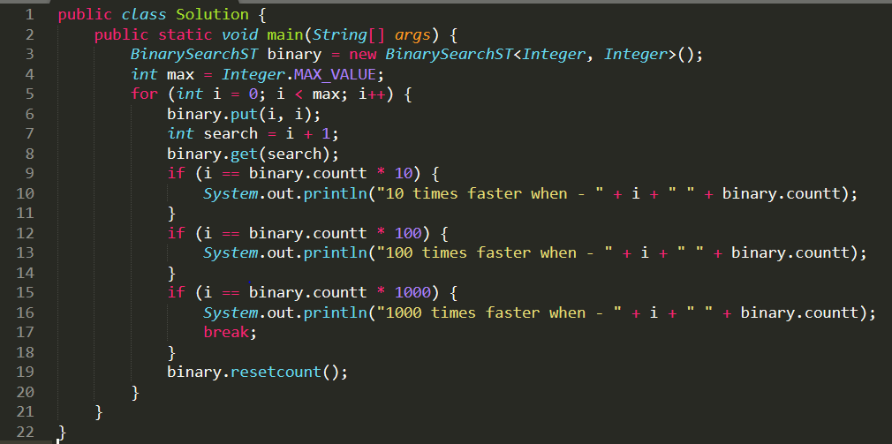

Search | Case | 10 | 100 | 1000
Sequential Search | Avg Case | 49 - 64 | 500 - 1091 | 499 - 12451
Sequential Search | Worst Case | O(58) | O(996) | O(13746)
Binary Search | Avg Case | log(49) - log(64) | log(500 -log(1091) | log(499)-log(12451)
Binary Search | Worst Case | O(log(58)) = O(5.80) | O(log(996)) = O(9.96) | O(log(13746)) = O(13.746)
Git ID: 72d90ca7b4800aa4b7a0e74a740b19b1e4e47efd

